

BIT 4107 – Mobile Application Development
ENHANCED PROFESSIONAL STUDENT LOGBOOK
Student Name: SHEILA WAITHERA MURIITHI
Admission Number: BIT/2024/32455
Academic Year: YEAR 4
Semester: SEM II
Lecturer: Mr. Nyoro

Contents
Quick Action feature 3
Registering of a patient for registered patients 3
Dispense in pharmacy module for registered patients 3
Reports in pharmacy module for registered patients 4
Tools used; 5
Personal reflection: 5

Quick Action feature

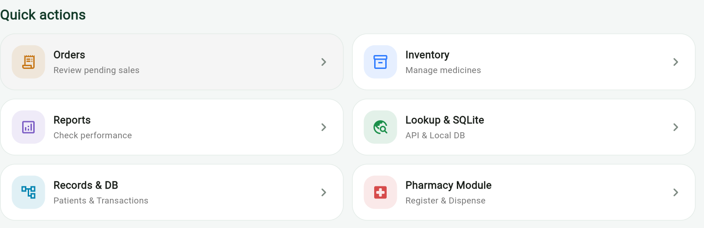

Registering of a patient for registered patients 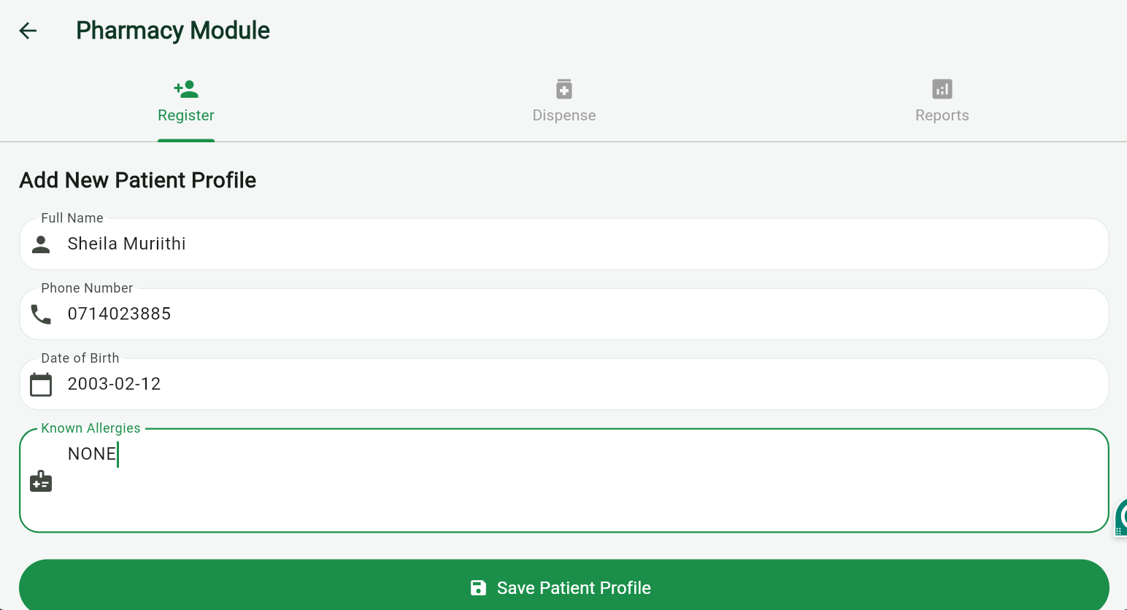

Dispense in pharmacy module for registered patients

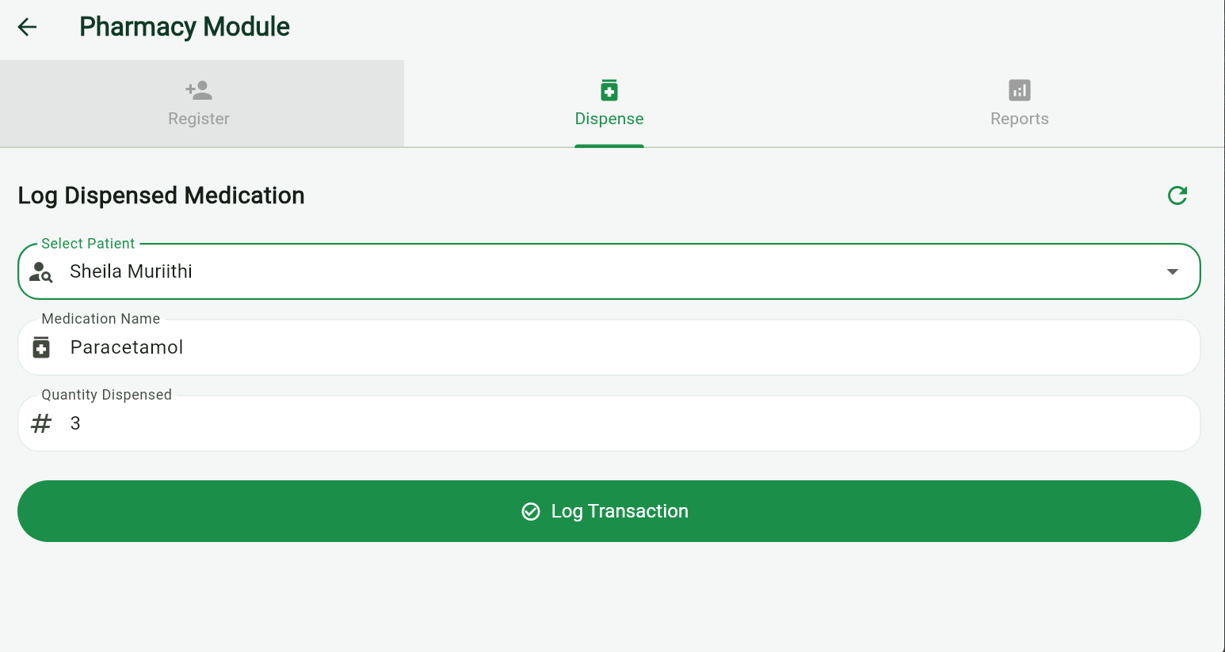

Reports in pharmacy module for registered patients

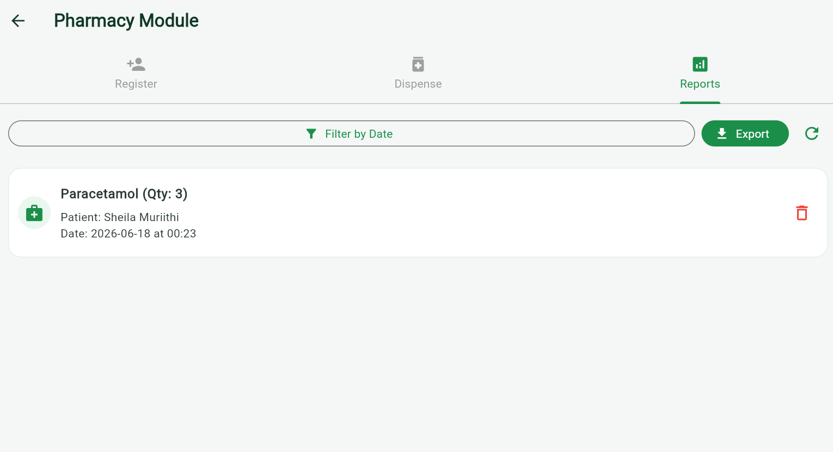

Tools used;

- Flutter (UI Framework)
- Dart (Programming Language)
- sqflite (SQLite Database Package)
- path (File Path Management Package)
- StatefulWidgets & setState (State Management)
- AutomaticKeepAliveClientMixin (Tab State Preservation)
- GlobalKeys (Form Validation & Cross-widget Communication)
- Clipboard (Flutter System Services for Exporting)
- kIsWeb (Flutter Foundation for Platform Detection)
- Dart Lists/Maps (In-Memory Database Fallback)

Personal reflection:
The Pharmacy Module highlights the importance of resilient architecture. Designing the seamless fallback from SQLite to in-memory storage, alongside auto-syncing tabs, transformed a basic CRUD screen into a robust, crash-proof tool. It’s a rewarding example of handling edge cases gracefully in Flutter.

